
database - logbook
By Aaron Cairns


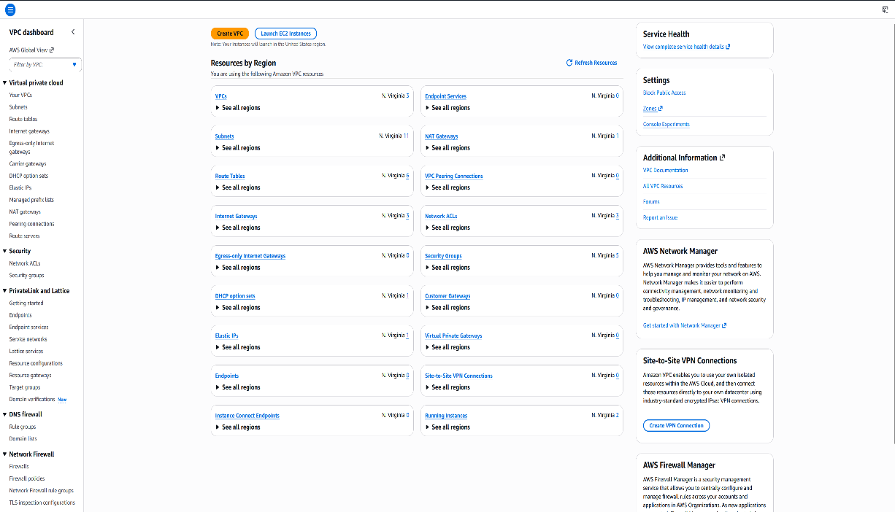
STEP 1: Security groups
I signed into the AWS Management Console and searched for the VPC service using the search bar at the top of the page. After opening VPC, I selected the Security Groups option from the left navigation menu.
I created a new security group called DB Security Group inside the Lab VPC. I added a description for the security group and prepared it to allow database traffic from the web server. Inside the inbound rules section, I added a new rule using the MySQL/Aurora type on port 3306. I selected the Web Security Group as the source so the web server could communicate with the database securely. I then created the security group.
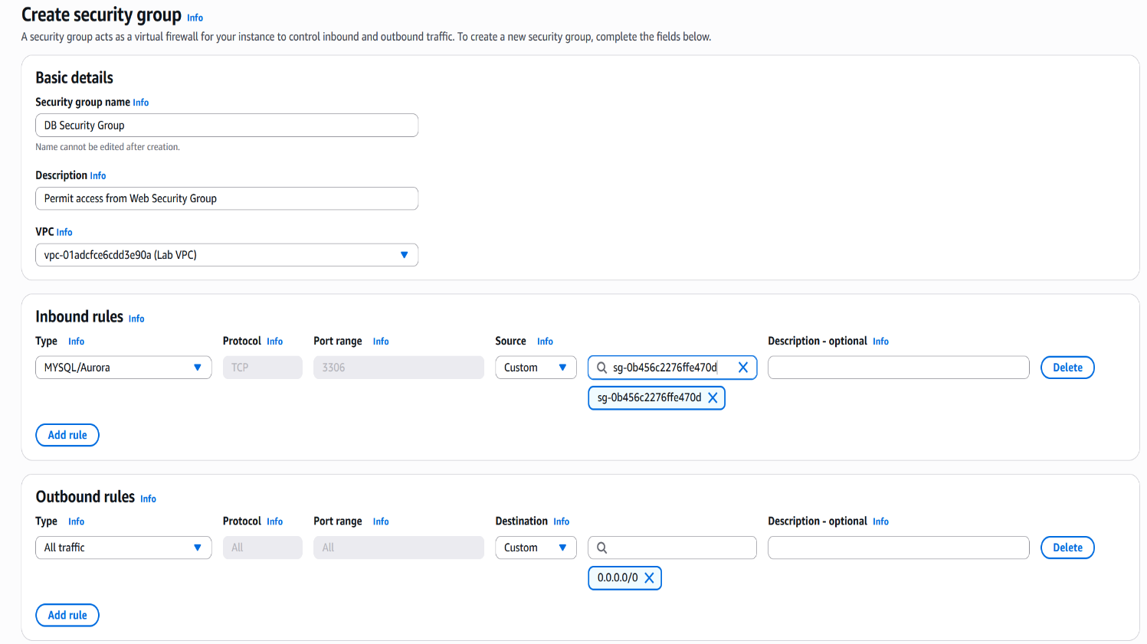

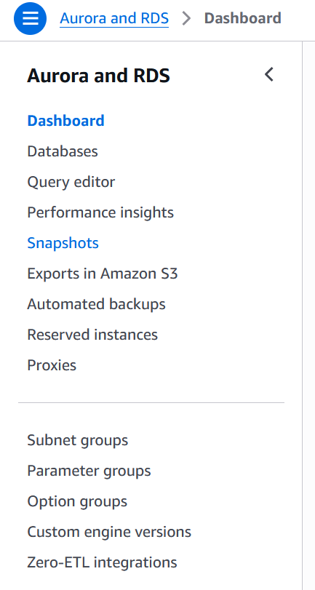
STEP 2: SUBNET
I searched for and opened the Amazon RDS service in AWS. From the navigation menu, I selected the Subnet Groups section to create a subnet group for the database deployment.

I created a subnet group called DB-Subnet-Group and linked it to the Lab VPC. This subnet group would define which subnets the database could use. I selected the availability zones us-east-1a and us-east-1b to support a Multi-AZ database setup. This configuration improves reliability by placing database resources across different zones. I selected the subnets using the CIDR ranges 10.0.1.0/24 and 10.0.3.0/24. These subnets were then added to the subnet group configuration and saved successfully.
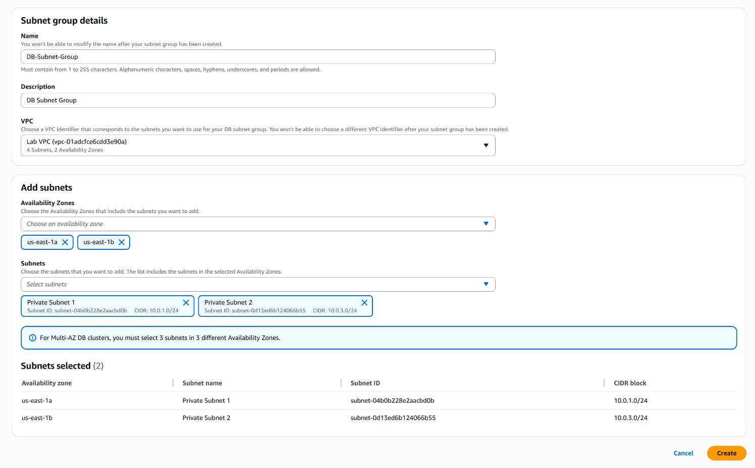
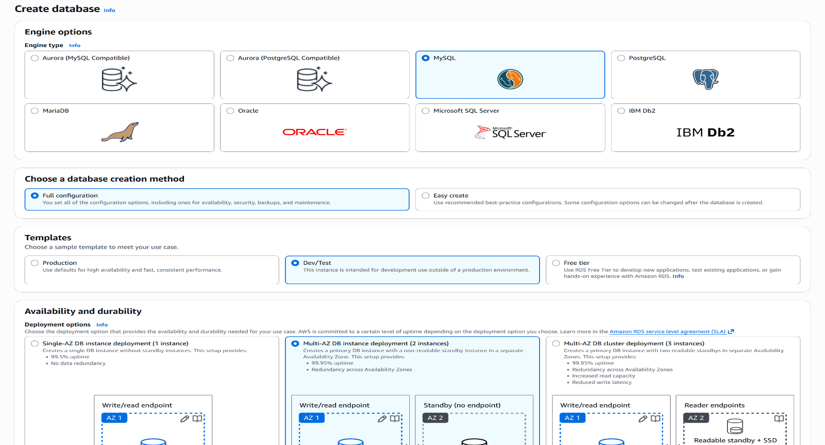
From the RDS dashboard, I selected Databases and clicked create database. I chose the MySQL engine option and selected the Dev/Test template for the setup. I selected the Multi-AZ DB instance deployment option to create a more reliable database environment. This would automatically replicate the database into a second availability zone.
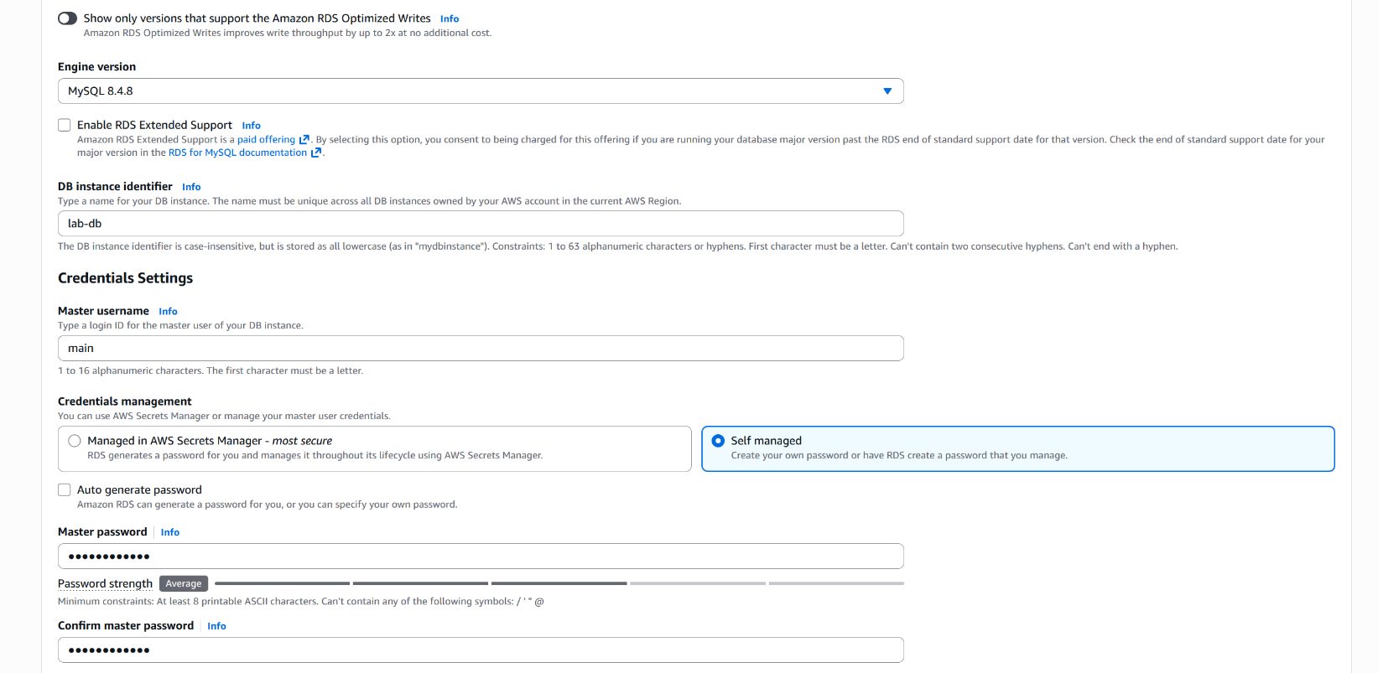
I entered the database identifier as lab-db and created the master username and password. These credentials would later be used to connect the web application to the database.
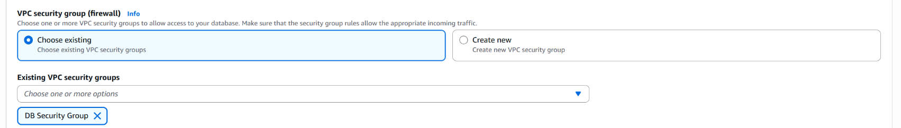
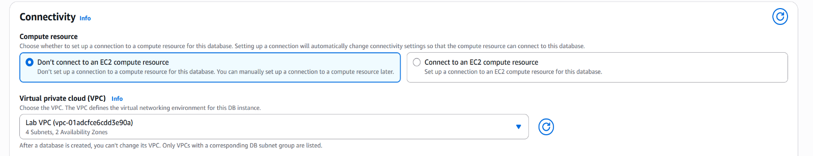
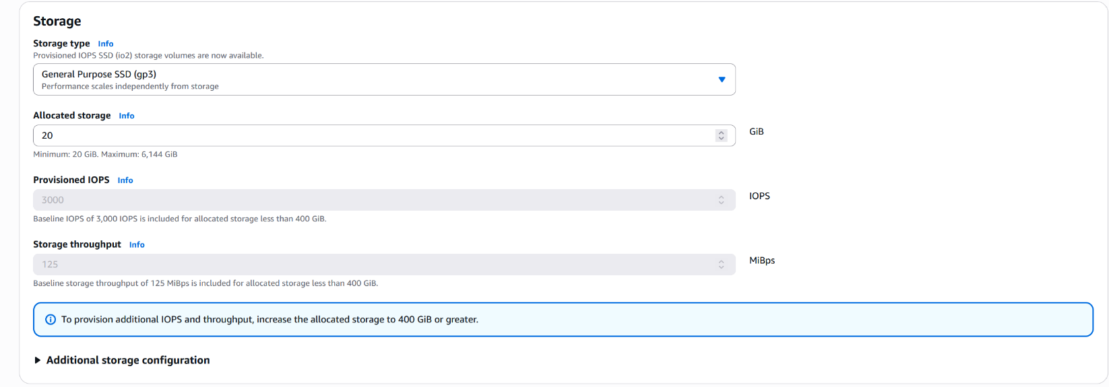
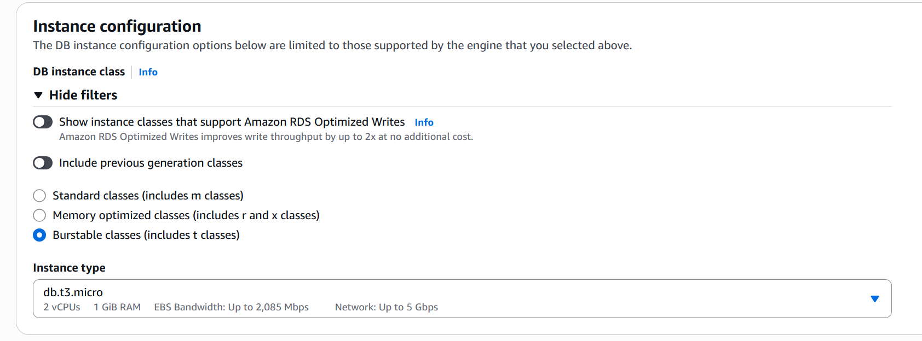
I selected General Purpose (SSD) storage and set the allocated storage amount to 20GB. This storage configuration was suitable for the database application used in the lab. I selected the Lab VPC and attached the DB Security Group to the database. I also removed the default security group to ensure only the configured web server could access the database.
I configured the instance class using the burstable classes option and selected db.t3.micro. This provided a small and cost-effective database instance suitable for the lab task.
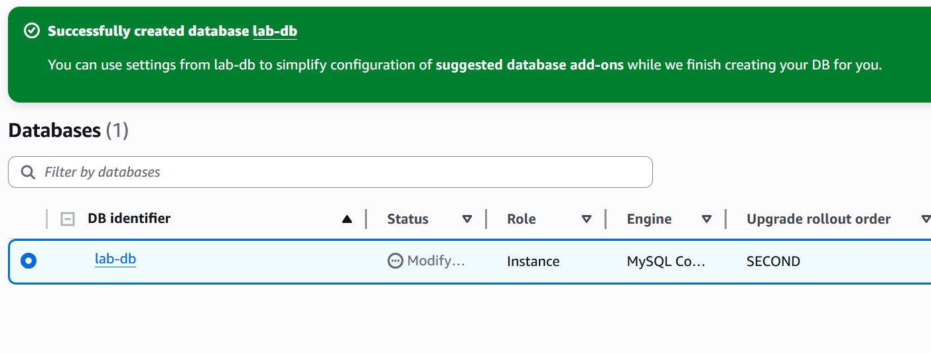
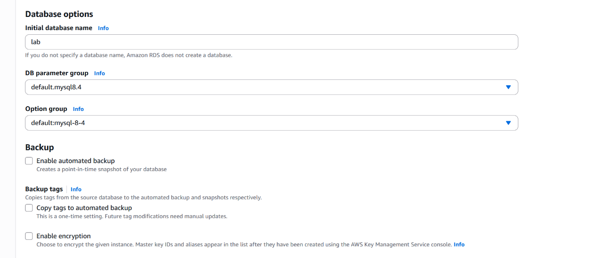
I clicked create database and waited for the database instance to finish deploying. After several minutes, the database status changed to modifying. Once the database was running, I opened the Connectivity & Security section and copied the database endpoint address. This endpoint would be used to connect the web application to the database.
I disabled Enhanced Monitoring, automatic backups and encryption to speed up the deployment process. I also entered lab as the initial database name before creating the database.
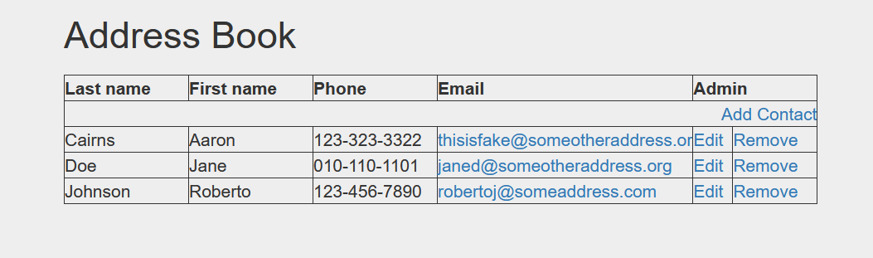
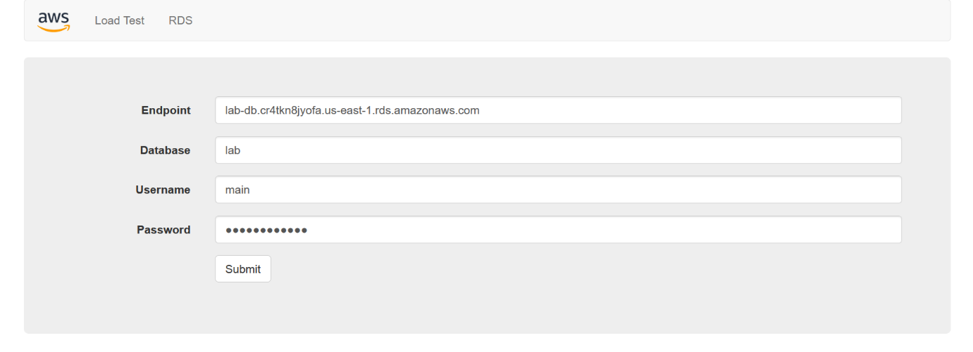
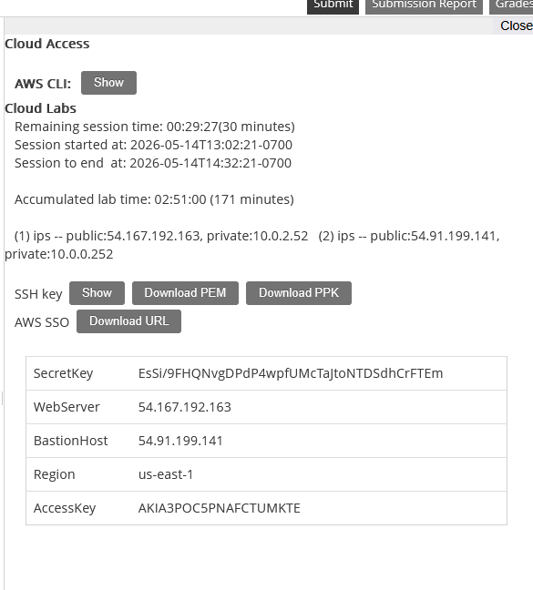
Finally, I tested the Address Book application by adding, editing and deleting contacts. This confirmed that the application was successfully storing and retrieving data from the Amazon RDS database.
Inside the web application, I opened the RDS section and entered the database endpoint, database name, username and password. After submitting the information, the application successfully connected to the RDS database.
I located the WebServer IP address from the AWS Details section and opened it in a new browser tab. This loaded the Address Book web application

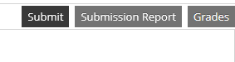
After completing the database instructions, I recorded my work by clicking “submit” and when prompted I clicked “yes”. I needed to wait a couple of minutes to receive my final grade. Once I received my grade I finished by clicking “end lab”.

